**THE NATIONAL INSTITUTE OF ENGINEERING, MYSURU**

(An Autonomous Institute under VTU, Belagavi)

**Bachelor of Engineering**

**in**

**Computer Science and Engineering**

**Operating Systems**

*Submitted by*

**Nishant Sharma 4NI19CS076**

**Harsh Babal 4NI19CS048**

Under the Guidance of

**Dr. Jayasri B S**

Professor

**DEPARTMENT OF COMPUTER SCIENCE AND ENGINEERING**2021-2022

**DEPARTMENT OF COMPUTER SCIENCE AND ENGINEERING**

**THE NATIONAL INSTITUTE OF ENGINEERING**

**(An Autonomous Institute under VTU, Belgavi)**



**CERTIFICATE**

**This is to certify the work carried out by Nishant Sharma (4NI19CS076),**

**Harsh babal (4NI19CS048) in partial fulfilment of the requirements for**

**the completion of tutorial in the course Operating System in the V semester, Department of**

**Computer Science and Engineering as per the academic regulations of The National Institute**

**of Engineering, Mysuru, during the academic year 2021-2022.**

**Signature of the Couse Instructor**

**Dr. JAYASRI B S -- Professor & Dean (EAB)**

**Table of Contents**

**SJF:**

|  |  |  |
| --- | --- | --- |
| **Sl no.** | **Contents** | **Page no.** |
| 1. | Description | 1 |
| 2. | Algorithm | 1 |
| 3. | Implementation and Output | 4 |
| 4. | Advantages | 7 |
| 5. | Disadvantages | 7 |

**FIFO:**

|  |  |  |
| --- | --- | --- |
| **Sl no.** | **Contents** | **Page no.** |
| 1. | Description | 8 |
| 2. | Algorithm | 8 |
| 3. | Implementation and Output | 9 |
| 4. | Advantages&Disadvantages | 11 |
| 5. | Github Links | 11 |

**Shortest Job First Scheduling Algorithm**

**Description:**

Shortest Job First (SJF) is an algorithm in which the process having the smallest execution time is chosen for the next execution. This scheduling method is non-preemptive, once the CPU cycle is allocated to process, the process holds it till it reaches a waiting state or terminated. If two processes have same burst time then FCFS (First Come First Serve) is used to break the tie. It significantly reduces the average waiting time for other processes awaiting execution.

**Algorithm:**

**Step1:** Take the set of processes as the input with the corresponding arrival time and burst time.

**Step2:** Sort these processes based on their arrival time and burst time in ascending order**.**

**Step3:** The process with least arrival time is executed completely and corresponding completion time, turn-around time and waiting time are updated.

**Step4:** The process that has arrived before the completion of current process execution and has the minimum burst time will be executed next.

**Step5:** Repeat Step4 until all the processes are executed completely.

**Implementation:**

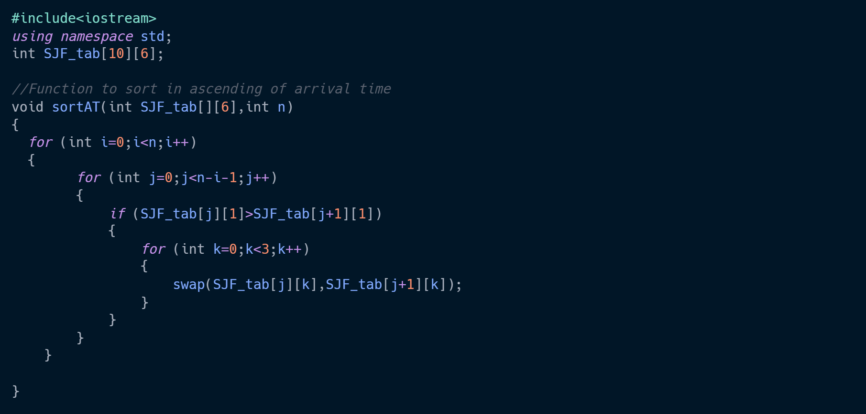

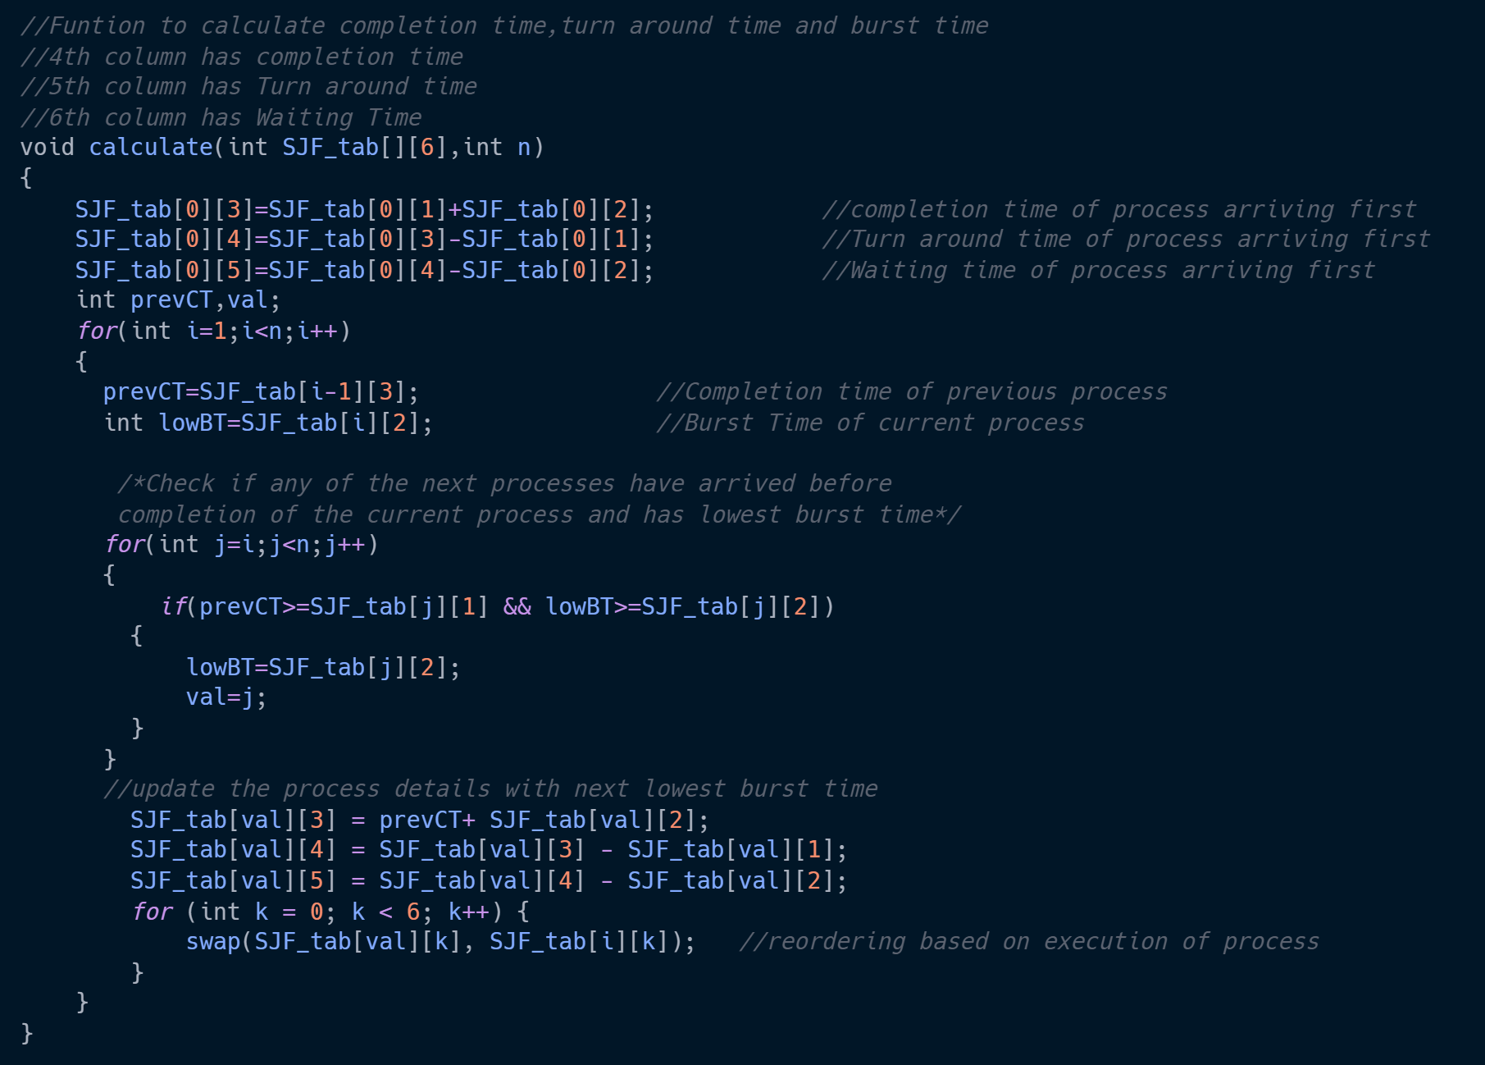

**Implementation:**

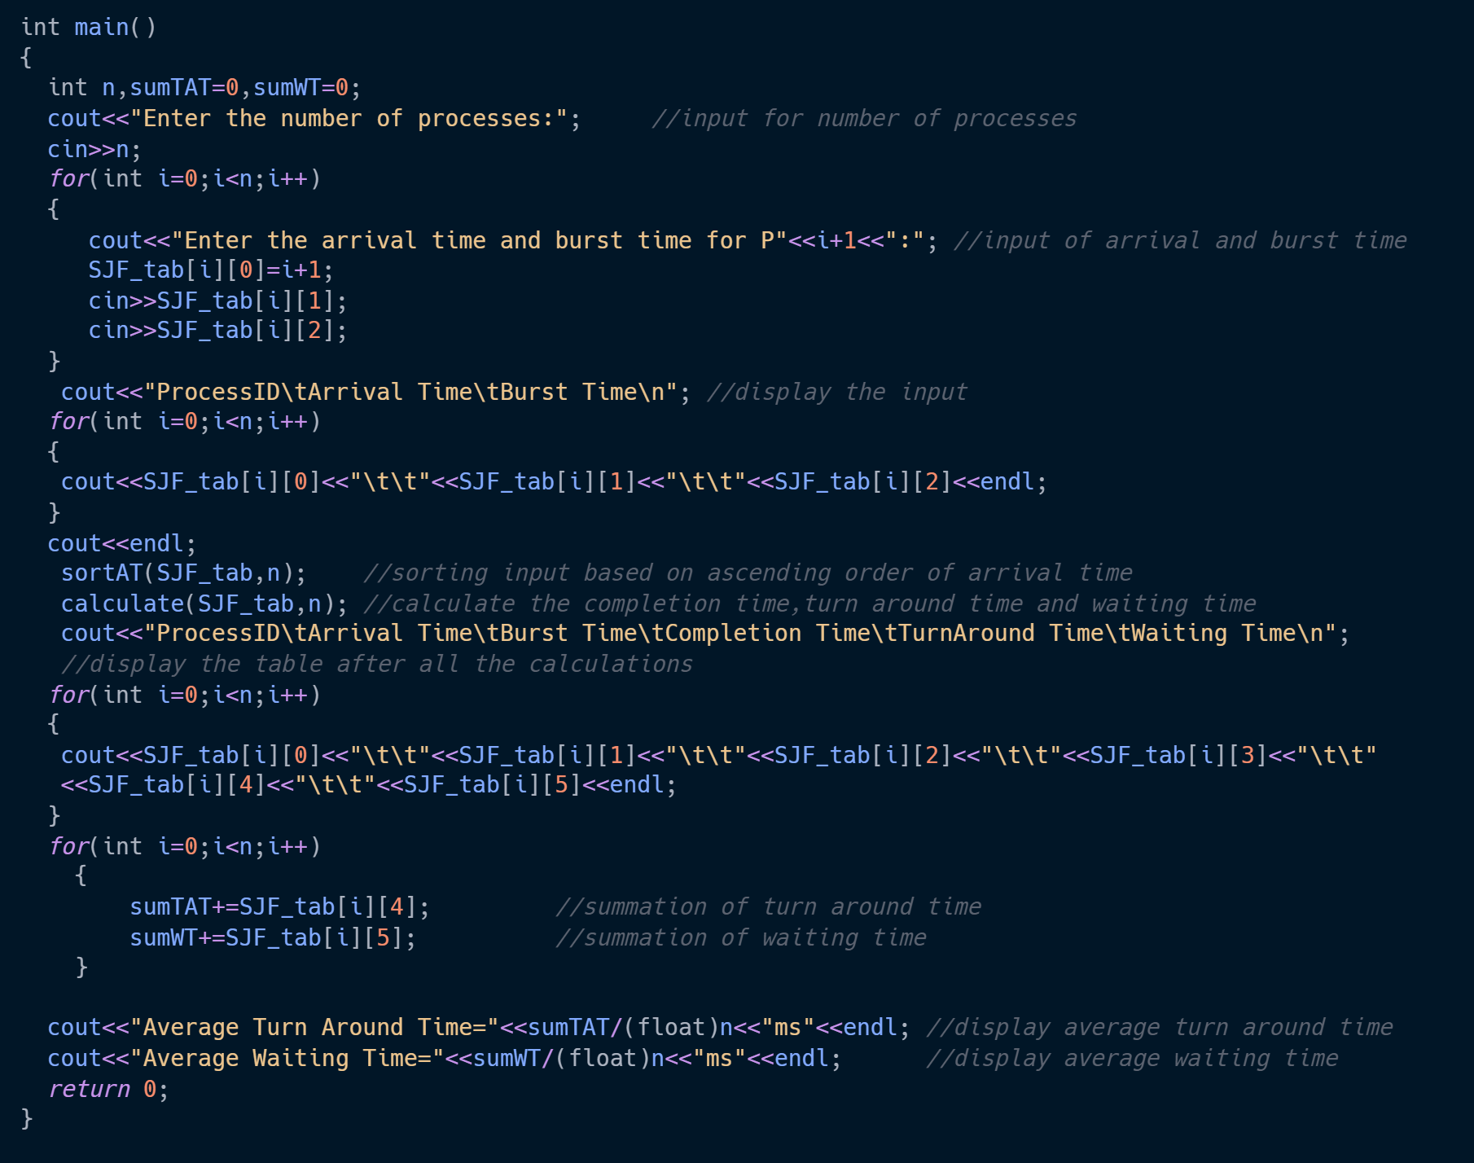

**Output:**

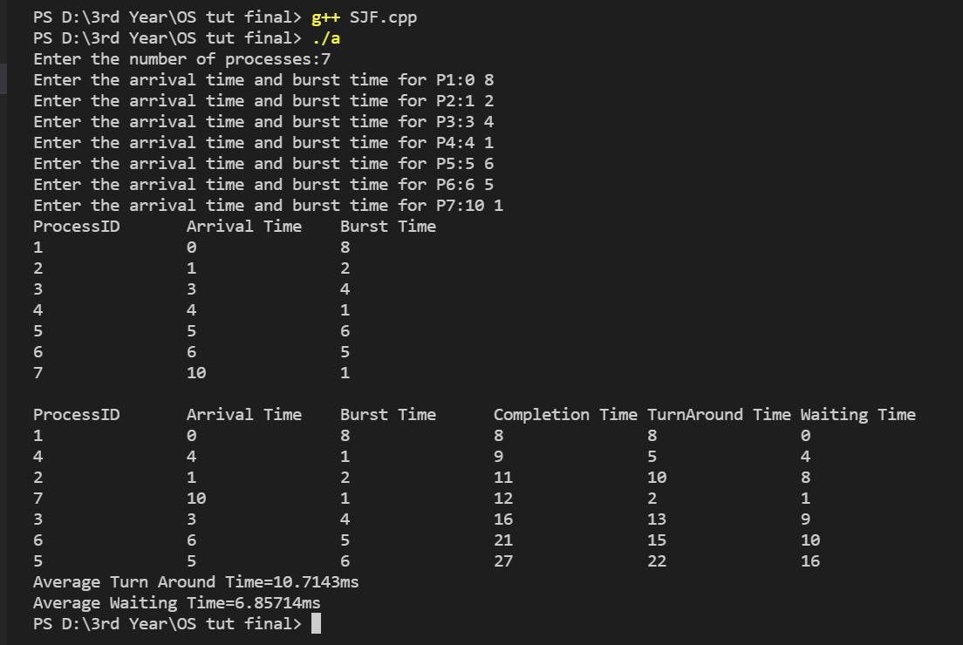

**Advantages:**

1. SJF is frequently used for long term scheduling.
2. It reduces the average waiting time over FIFO (First in First Out) algorithm.
3. It is appropriate for the jobs running in batch, where run times are known in advance.

**Disadvantages:**

1. Job completion time must be known earlier, but it is hard to predict
2. May suffer with the problem of starvation.
3. SJF can’t be implemented for CPU scheduling for the short term.

**FIRST IN FIRST OUT PAGE REPLACEMENT ALGORITHM**

**Description:**

This is the simplest page replacement algorithm. In this algorithm, the operating system keeps track of all pages in the memory in a queue, the oldest page is in the front of the queue. When a page needs to be replaced page in the front of the queue is selected for removal.

**Algorithm:**

1- Start traversing the pages.

i) If set holds less pages than capacity.

a) Insert page into the set one by one until

the size of set reaches capacity or all

page requests are processed.

b) Simultaneously maintain the pages in the

queue to perform FIFO.

c) Increment page fault

ii) Else

If current page is present in set, do nothing.

Else

a) Remove the first page from the queue

as it was the first to be entered in

the memory

b) Replace the first page in the queue with

the current page in the string.

c) Store current page in the queue.

d) Increment page faults.

2. Return page faults.

**Implementation:**

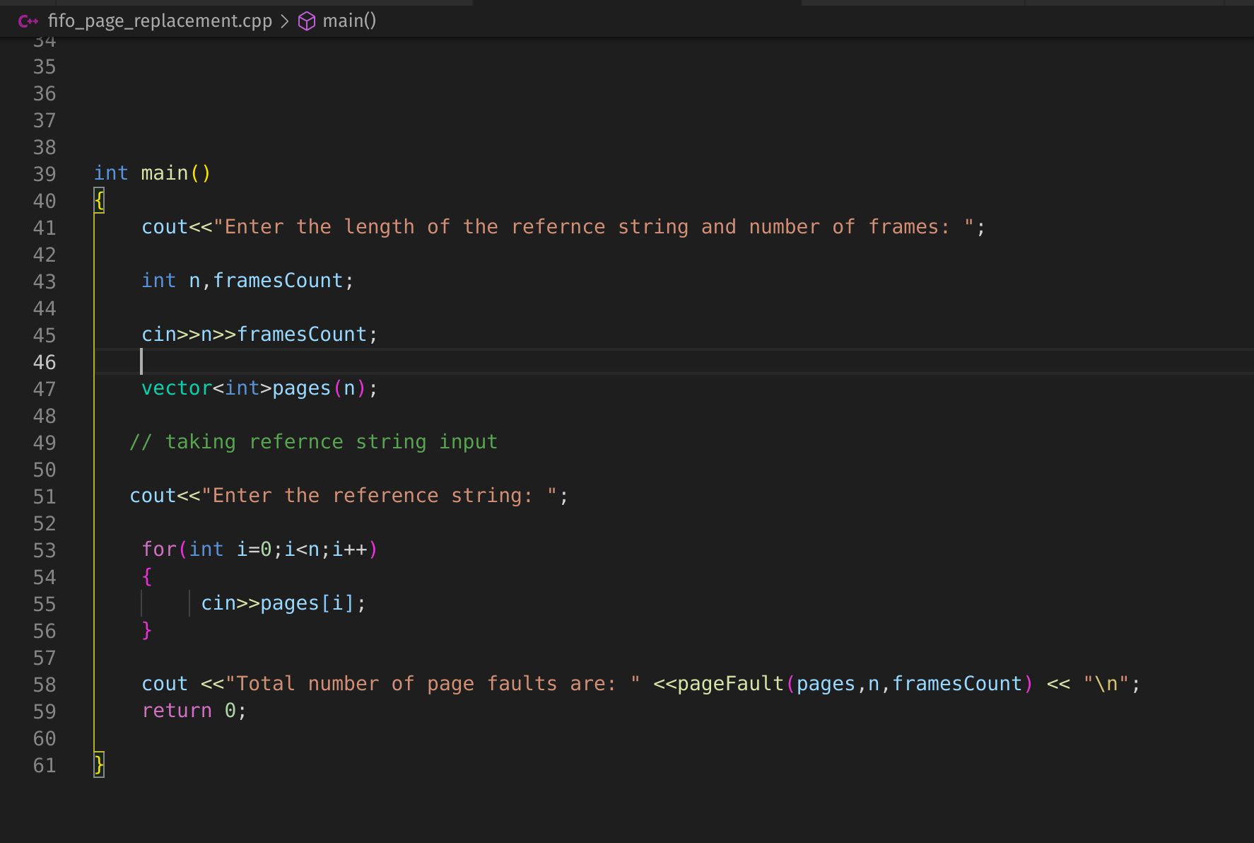

**IMPLEMENTATION:**

**INPUT & OUTPUT:**

**Advantages:**

1. It is simple and easy to understand and implement.
2. Easy to choose the page which needs to be replaced.

**Disadvantages:**

1. The process effectiveness is low.
2. When we increase the number of frames while using FIFO, we are giving more memory to processes. So, page fault should decrease, but here the page faults are increasing. This problem is called as Belady’s Anamaly.

**Github Links:**

**Nishant Sharma -https://github.com/nishantsk?tab=repositories**

**Harsh Babal**